**Herbie – an Arduino based animatronic dinosaur**

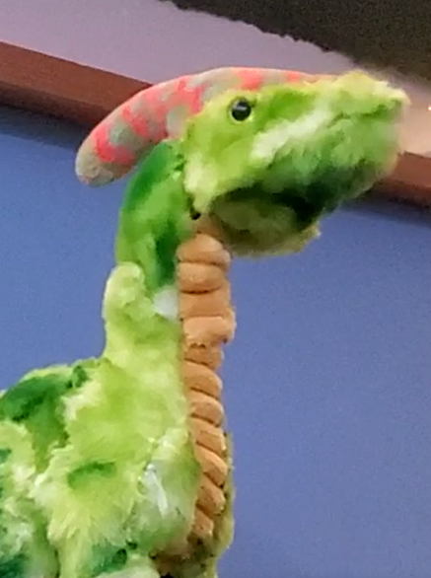

**Introduction**

I was first introduced to Electronic Engineering and microcontrollers 3 years ago when I received an Arduino beginners kit for my birthday. About half a year into making Arduino-based projects, I built an animatronic dinosaur head made mostly out of cardboard, LEGO pieces and hot glue. That project greatly inspired me to continue to pursue the field of robotics, since I saw so much potential in it. You can see the robot working by following this link: <https://youtu.be/RmMfcYAmR_A>

An animatronic is a mechanical puppet; a robot that is often controlled with a person’s body motion[1]. They are used in film industry, amusement parks, and more since their motion comes out smooth and realistic due to the real nature of the motion.

My idea was to make a Parasaurolophus robot that would look like one, would have enough degrees of freedom to move realistically, and could make sounds. It is worth mentioning that, initially, I was planning on the robot to move independently and act more like a pet interacting with its environment. However, I really wanted for this project to be an improvement on my very first animatronic, so instead I decided to make it controlled with my arms’ movements by having relevant sensors attached to them.

**Initial research**

I started building the robot relatively recently, only during the first term of year 13. This was due to covid complications and me being in Russia, whilst my electronic components were in the UK and vice versa. That said, there was a lot of research to be done before the start of the building process.

First, I had to research on animatronics in general. I had to find out what were the basic principles behind them, how the building approach differs depending on your scale and what are the tricks to making good animatronics. The videos by DiscoveryUK[2] and Adam Savage[3] gave a very informative insight on these very topics, giving me a solid idea on where to look next.

One of the most often recurring concepts in the sources that I’ve encountered was the idea of moving the driving motor away from the driven joint. Most of the time the most articulate parts of the body (head, arms) are much smaller than the less articulate ones (body, legs). This means that the motors driving small joints might not always fit inside the small space you’re working with. There are different ways to approach this problem, but the core concept is transferring torque and motion through gear mechanisms, linkages, or wires.

Another useful resource was a YouTube channel run by Will Cogley[4], where he builds a robotic hand, eyes, mouth, and other body parts, which were an excellent example of the kind of mechanisms I’ll be building since these projects were about of the scale I was going for with my dinosaur.

**Developing initial practical skills**

One of the major challenges I had to overcome was getting the mp3 module to work. I implemented tens of examples of code I found online and only after a month did I manage to make it make sounds thanks to this great video by a Russian youtuber “Home Made”[5]. To test that I am able to work with the module, I made a “Pickle Rick” toy using it, which you can see by following this link: <https://youtu.be/_tUxfG1Ddo8>

The next important skill I had to acquire was 3D modelling. A lot of the components in my robot had to be of very specific shapes and 3D printing was the way to make them. I followed an incredibly detailed and intuitive tutorial[6] by Alex Gyver on how to use Fusion 360 – 3D modelling software. I built a tiny robotic octopus to gain the initial experience and some basic intuition with the technique, so that I feel confident enough to model the dinosaur. You can see the octopus by following this link: <https://youtu.be/6QByXtD9irc>

**Making the head with the neck**

I started by putting together a few mechanisms for the neck and the head joints out of LEGO pieces. I discarded several of them on the way because they were bulky and did not allow for a wide range of motion I was going for. It was tricky to fit the 4 head and 1 neck axes of movement while not restricting some joints with the other ones. That said, I managed to save a lot of space by utilising two universal joints. The design ended up working perfectly as I wanted it to, so I decided to leave it as it is: made mostly out of LEGO pieces.

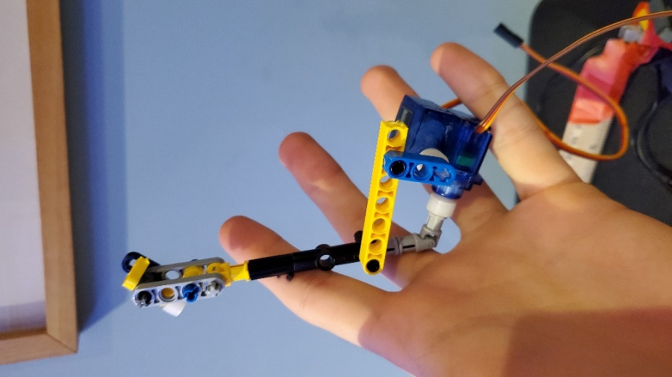 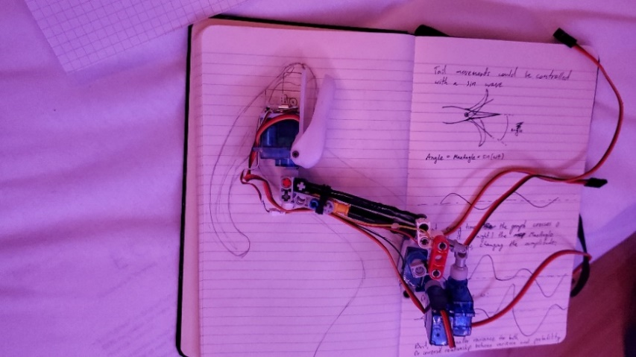

Once I had some of the mechanisms ready, I started sketching the scale of the dinosaur, the size of the head, and how the motors could be arranged in it. As I already mentioned, the challenge was to make everything as compact as possible. The head had to hold a motor to manipulate the jaw and a motor to control the roll of the head. I went with a regular 9-gram servo and a tiny linear actuator for the roll and the jaw respectively, which, just as all other servomotors, have been purchased from AliExpress. The servo worked great, however the actuator burned twice, since, apparently, it couldn’t cope with the load. I had to replace it with a small rotational servo instead.

To mount the motors, I designed and 3D-printed the upper and lower jaw pieces for the head which did take 10-15 iterations to get right. I decided to print everything in white PETG, because it is famous for its strength and durability. The lower jaw also housed a speaker.

Once I had the head and neck joints ready, I reprogrammed an old remote I made and used it to test the joints and their motion. You can watch the video of the test by following this link: <https://youtu.be/Bdx5gRsY6Ws>

**Making the arms and lower body**

Parasaurolophus’s arms are rather small, and I did not plan to make them very articulate, so I had to come up with a mechanism that would give the arm’s motion some complexity while only requiring a single driving servomotor per arm. Using only two motors was necessary to minimise the occupied space and pins used on the microcontroller. I designed a series of linkages that would move between two positions similar to the two positions of the Parasaurolophus’s arms you can see in the image[7] below. You can also see the mechanism in action by following this link: <https://youtu.be/IHqLKB-stus>

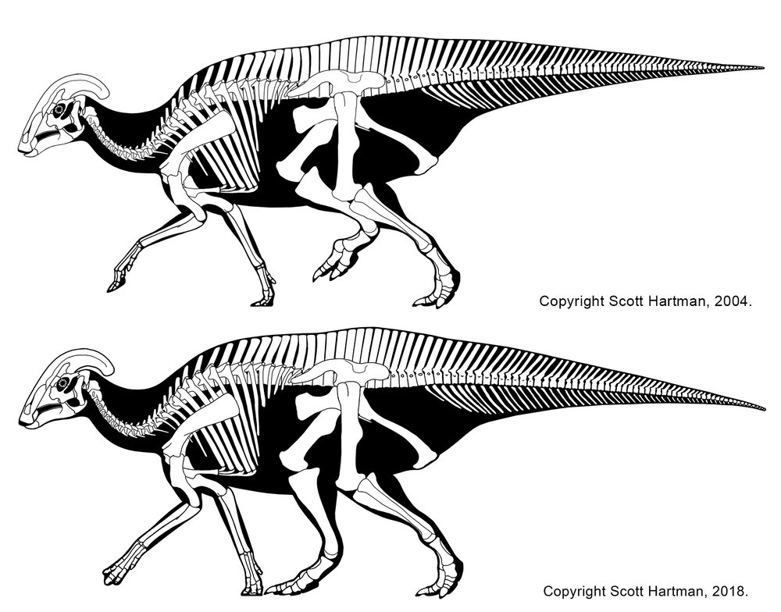

I decided for the legs to be stationary and hard attached to the base the robot will be standing on. This decision was made because the legs would need to support the weight of the robot and they didn’t need to be very articulate in the first place. Needless to mention that making the robot walk is a degree-level project and would have been largely overly ambitious to attempt.

Because of the high load on the hips of the robot, I decided to use a bigger servo with higher torque. Since the legs were attached to the base, I was able to place the battery and the voltage converter in the base and only pass the two power wires into the robot through the legs.

Next, I modelled the body piece that would connect the legs, the neck and, later, the tail together. It would also hold the electronic components. It was split into several parts for better printing quality and rapid prototyping speed. You can see the second motion test with the body piece by following this link: <https://youtu.be/ZLnlisCycTQ>

The last body part to make was the tail. The tail was inspired by the mechanism I saw in an Adam Savage’s video[8] about a mechanical hand. The mechanism allowed for the curving motion of the limb, while only requiring one motor. The amplitude of the curvature can be tuned using different gear ratios and “vertebrae” lengths. You can see the test of the tail’s motion by following this link: <https://youtu.be/_PuAKV0-Cwc>

I later added the microcontroller board with a nrf24l01 radio transmitter for wireless communication and an mp3 module and connected all of the servomotors.

Once all of the mechanical and electronic design of the robot’s inside was complete, I had to make it look good on the outside.

**Fabric work**

There were a few options on what to make the outside of the dinosaur out of. I could have made a silicone moulded “skin” or design a 3D-printable shell. However, both solutions were quite complicated and came with their own drawbacks.

The silicone is rather heavy, which is a problem for my small weak servomotors, and it is not easy to work with at all. Making a realistic dinosaur out of silicone could have been an EPQ project on its own, and it would have been more of an artistic one.

The 3D-modelling approach wouldn’t have allowed for the “skin” of the dinosaur to stretch, bend or fold due to the rather rigid nature of 3D-printing.

I settled on a plush toy solution, where I had to find a suitable Parasaurolophus toy and use its fabric to cover my robot. I found the one by AURORA[9] to be perfect for the job: it was about of the scale I was going for; its body parts were thick enough to fit the mechanisms inside of them; and it actually looked good. I can’t say that a lot of other Parasaurolophus plushies satisfied all of these criteria.

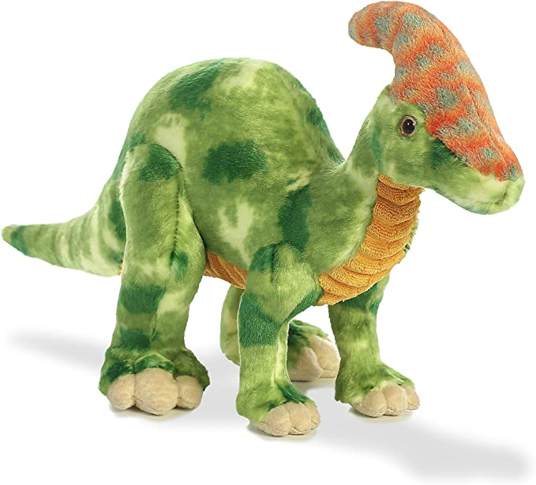

Once I found the right toy, I used it as a reference for all my scales and sizes, since the robot had to be built around it. I even had to do some more 3D-modelling to design special brackets with holes for the head to hold the fabric to it.

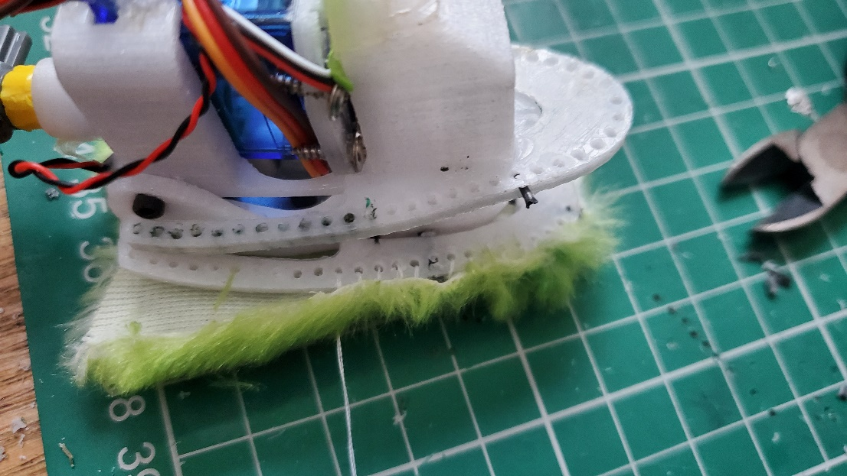

Once the mechanical parts were ready, unfortunately, it wasn’t as simple as putting the whole thing over the robot like a costume. I had to stitch different parts of the body in one at a time, adding extra fabric in different places to make sure everything is as little restricted by the fabric as possible. That said, it didn’t work entirely. As you can see in this video, the motion became much less articulate with the fabric: <https://youtu.be/tLnBLJNBaIk>

Furthermore, on the very last day of testing, 3 of the 9 axes of movements broke because of the resistance of the fabric: all in the span of a minute. That was rather upsetting, since quite of an important axis – the head’s yaw – was one of them. That said, 6 axes were still enough for the robot to move well and for me not to call the project a failure.

**Control gloves**

Now, once the robot was ready, it was time to replace the temporary old remote controller with what I initially wanted the robot to be controlled with - a pair of gloves that would take my arms’ movements as input and manipulate the robot according to it.

I used gardening gloves as a base for the main electronics, which consisted of: an RF-Nano board, which is a microcontroller with an nrf24l01 radio module embedded into it, which saved me a lot of space; an MPU6050 accelerometer for measuring the pitch and roll of the hand; a battery to power it all and a voltage converter from the battery’s 3.7v to the 5v the electronics need. You can watch a more detailed description of what the gloves do by following this link: <https://youtu.be/4y9ulJJI83c>

I used a potential divider circuit for the 4 buttons on my left hand to minimise the number of wires I needed for them from 4 to just 1.

A greater challenge was connecting multiple accelerometers to the microcontroller, since they communicate via I2C and only have 2 different addresses they could be set to (when you talk to an I2C device, it must have a unique address). The solution was to set the accelerometer I want to talk to to address A, while setting all the other ones to address B, and then, when sending a request, send it to address A, which, at that moment in time, is a unique address. It was a rather elegant solution, which took me a few weeks to get to.

**Final touches**

I was thinking of the sounds the robot should make. I thought about making it speak, but that didn’t really fit with the idea of the robot being realistic. So, I went with regular “dinosaur sounds”. However, since Parasaurolophuses had a bone crest that they used to make sounds, it has been preserved in the fossils, and scientists managed to recreate what these dinosaurs sounded like using the 3D models of these fossils. I found the video[10] with these sounds, split it up into different files and assigned different sounds to different buttons on the control glove.

I found using the actual sounds we think Parasaurolophuses used to make, instead of the basic “rawr”s used in movies, to be a nice touch to the project.

**Final Product**

The final robot turned out great. It was next to everything I expected it to be. Even with the missing degrees of freedom, it moved great. It made people who saw or interacted with it smile, which is really what the ultimate goal for it was. You can watch the video of the final working version of the robot by following this link: <https://youtu.be/mOdtYL-Y_sU>

I am happy with the result, but it really was more about the journey for me. This project has allowed me to largely develop my skills in a wide range of fields: electronics, mechanisms design, materials work, engineering, 3D-modelling, programming, debugging, rapid prototyping, stitching and sewing, and a lot more. Not to mention the other side of it: the research skills, the ability to manage and recall your sources and the ability to log and document your working process for other people to be able to follow through, which is a very important skill for an engineer I want to be.

**Bibliography**

Adam Savage's new mechanical claws! (2020, April 20). Retrieved January 3, 2022, from https://youtu.be/nbKG9SjZjvQ

Adam Savage's new mechanical claws! (2020, April 20). Retrieved 2021, from https://youtu.be/nbKG9SjZjvQ

Animatronics. (2022, January 1). Retrieved 2021, from https://en.wikipedia.org/wiki/Animatronics

Arduino MP3 module tutorial - WTV020SD16P: Code, Connect, and run! (2018, May 18). Retrieved 2021, from https://youtu.be/BZ6SuWlAZ5o

ElectronicCats. ElectronicCats/MPU6050: Mpu6050 Arduino Library. Retrieved 2021, from https://github.com/ElectronicCats/mpu6050

Fusion 360 tutorial for absolute beginners (2020). (2019, September 6). Retrieved 2021, from https://youtu.be/qvrHuaHhqHI

Hand-sewing: Basic stitches and techniques. (2015, August 2). Retrieved 2021, from https://youtu.be/1FknfumFPX8

How DF player Mini Play Audio File: DF player to Arduino Interface: Fair electro. (2020, August 18). Retrieved 2021, from https://youtu.be/azcRVLsgWF0

How to hand sew an invisible stitch (tutorial). (2014, October 17). Retrieved 2021, from https://youtu.be/WbE5hXt27uU

igor1silenok. (2018, February 1). Мини MP3 плеер и Ардуино. Retrieved 2021, from https://www.youtube.com/watch?v=ZIDVUgiN1b4

Keywish RF Nano for Arduino Nano v3.0 ATmega328P integrate NRF24L01+. Retrieved 2021, from https://www.aliexpress.com/item/32980796969.html?spm=a2g0o.productlist.0.0.2a5a6f41pyUjUe&algo_pvid=1e5ca417-0797-4945-9a11-f9146d29a6d8&algo_exp_id=1e5ca417-0797-4945-9a11-f9146d29a6d8-0&pdp_ext_f=%7B%22sku_id%22%3A%22-1%22%7D

MPU6050. Retrieved 2021, from https://www.arduino.cc/reference/en/libraries/mpu6050/

Orlandoo Hunter 2G Digital Servo 2.2G servo for micro model airplanes cars trucks Orlandoo Hunter upgrade parts universal: Parts & Accessories: - aliexpress. Retrieved 2021, from https://www.aliexpress.com/item/1005001543863068.html?spm=a2g0o.productlist.0.0.5dd21852sKyZye&algo_pvid=5035c501-d986-47ad-9da8-1508c3c19b67&algo_exp_id=5035c501-d986-47ad-9da8-1508c3c19b67-0&pdp_ext_f=%7B%22sku_id%22%3A%22-1%22%7D

PETG 3D printer filament 1.75mm 1 kg spool, Sunlu petg filament white 1.75 +/- 0.02 mm for 3D printing. Retrieved 2021, from https://www.amazon.co.uk/Printer-Filament-SUNLU-Dimensional-Accuracy/dp/B082Y13L1R/ref=sxts_rp_s1_0?crid=WGUK631BL99Z&cv_ct_cx=petg%2Bfilament&keywords=petg%2Bfilament&pd_rd_i=B082Y13L1R&pd_rd_r=20a6a997-f1c5-4720-b183-971327fe567b&pd_rd_w=ziEZS&pd_rd_wg=wGUB6&pf_rd_p=b72cf2b4-1324-4800-968f-62743f330157&pf_rd_r=CX2ND0EREAN79H240AR5&psc=1&qid=1641218066&sprefix=petg%2Bfilament%2Caps%2C64&sr=1-1-1890b328-3a40-4864-baa0-a8eddba1bf6a

Мини MP3 плеер и Ардуино. (2018, February 1). Retrieved 2021, from https://youtu.be/ZIDVUgiN1b4

🤓Строим 3D модели во fusion 360. Большой гайд. (2020, April 21). Retrieved 2021, from https://youtu.be/I8-h8mLnexw

1. Animatronics. (2022, January 1). Retrieved 2021, from https://en.wikipedia.org/wiki/Animatronics
2. DiscoveryTV. (2019, August 17). Animatronic dinosaurs | how it's made. Retrieved 2021, from https://www.youtube.com/watch?v=kBt-0SfmPWg
3. The series of videos by Adam Savage in collaboration with Animax have been deleted from his YouTube channel due to too much confidential information about the making of the robots being exposed in them. I am therefore unable to sight them.
4. Will Cogley. Retrieved 2021, from https://www.youtube.com/c/WillCogley
5. Мини MP3 плеер и Ардуино. (2018, February 1). Retrieved 2021, from https://youtu.be/ZIDVUgiN1b4
6. 🤓Строим 3D модели во fusion 360. Большой гайд. (2020, April 21). Retrieved 2021, from https://youtu.be/I8-h8mLnexw
7. Hartman, S. (2018, November 30). The hadrosaur repose of 2018DR. Scott Hartman's skeletal drawing.com. Retrieved 2021, from https://www.skeletaldrawing.com/home/the-hadrosaur-repose-of-201811272018
8. Adam Savage's new mechanical claws! (2020, April 20). Retrieved 2021, from https://youtu.be/nbKG9SjZjvQ
9. Aurora, 60690, Parasaurolophus Dinosaur,14in, soft toy, green : Amazon.co.uk: Toys & games. Retrieved 2021, from https://www.amazon.co.uk/gp/product/B01J5UEJF2/ref=ppx_yo_dt_b_search_asin_title?ie=UTF8&psc=1
10. Real dinosaur sounds: Parasaurolophus. (2017, August 20). Retrieved 2021, from https://youtu.be/Y-td6L1L6uk